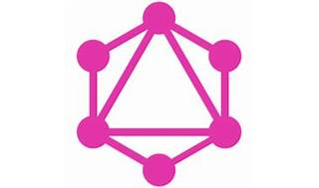

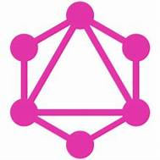

Explore

**GraphQL** is a query language that provides a more efficient, flexible, and powerful way of working with APIs compared to REST. [It allows clients to request exactly the data they need and nothing more, making it easier to evolve APIs over time1](https://www.coredna.com/blogs/what-is-graphql).

Here are **five free resources** where you can learn more about GraphQL:

1. [**GraphQL Official Documentation**](https://graphql.org/): Explore the official documentation to understand the core concepts, how GraphQL works, and how to use it in your projects[2](https://graphql.org/).
2. [**How to GraphQL**](https://www.howtographql.com/): This comprehensive tutorial covers everything from the basics to advanced concepts, including Apollo, Relay, React, and NodeJS[3](https://www.howtographql.com/).
3. [**Learn GraphQL on Hackr.io**](https://hackr.io/tutorials/learn-graphql): Discover a curated list of online courses and tutorials recommended by the programming community. [Choose the one that suits your learning style](https://www.coredna.com/blogs/what-is-graphql)[4](https://hackr.io/tutorials/learn-graphql).
4. [**codedamn’s GraphQL Interactive Course**](https://codedamn.com/learn/graphql-for-beginners): Dive into introductory and advanced GraphQL topics, including creating your own GraphQL API using NodeJS and integrating it with ReactJS[5](https://codedamn.com/learn/graphql-for-beginners).
5. [**GraphQL Community Reviews**](https://dev.to/apollographql/my-favorite-resources-for-learning-graphql-30gc): Check out community reviews and recommendations for various GraphQL resources, including articles, workshops, and glossaries[6](https://dev.to/apollographql/my-favorite-resources-for-learning-graphql-30gc).

Happy learning! 🚀